The Conscious Competence Learning Model (1970s)
The origins of this model remain unknown, but it was first clearly defined by Noel Burch who worked for US Gordon Training International Organisation back in the 70s.

The best way to understand this model, which tries to explain how we get better at acquiring a skill, is to think back when you were first trying to learn to ride a bike or drive a car.

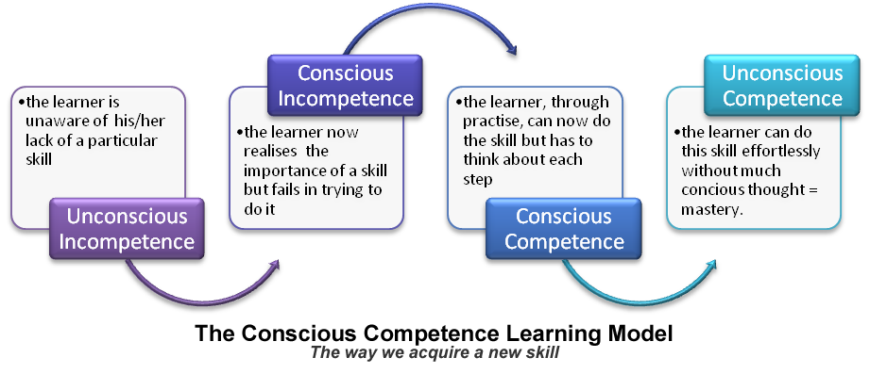
Learners can feel uncomfortable during the conscious incompetence and conscious competence phases. But uncomfortable feelings are good because they mean one is no longer in their comfort zone but on the journey to their desired state. Sometimes learners need to be reminded of this to help dampen any feeling of despair. Unconscious competence can only be achieved through practise, practise and practise (at the conscious competence stage). Once at this ultimate desired destination, any feelings of discomfort simply fade away.
How to Use These Models
- As originally intended, these can help us formulate our objectives for a teaching session, course, programme or curriculum – what do we wish to focus on (in terms of knowledge, skills and/or attitudes) and to what level. If you’re ever stuck when trying to figure out your aims and objectives, always consider mapping them out in relation to knowledge, skills and attitudes.
- As with any checklist, it helps to reduce the risks of overlooking some vital aspect of an educational session. Considering the knowledge, skills and attitudes (and their sublevels) of a particular topic forces us to take a holistic approach.
- Help us identify where trainees are in the learning process and therefore help identify their needs. Taking the clinical area of sexual health as an example: is the trainee’s knowledge up to scratch or do they now need to start focussing on practising taking a sexual history or examination skills or do we need to look at their attitudes towards sexual practises and moral views?
- Help us plan a set of training sessions in a constructivist way: building on knowledge first, then skills and then attitudes (and progressing through the taxonomy of each one before moving to the next).
- Help an educator realise what (s)he needs to do to move a trainee onto the next learning level within a domain – even the trainees that seem to be excelling. The levels within the domains can be used to provide a basis for questioning that ensures trainees progress to the next level.
- Help us plan the learning process itself: selecting methods/activities to match the objectives. For example, if one wanted to teach on ‘how to examine the knee joint’, there is probably little point in just explaining how to do it or providing written instructions. Practise is going to be the key (practise is always the gold standard when teaching skills).
- Help us tell our trainees exactly what we expect from them; what one needs to achieve in terms of knowledge, skills and attitudes and to what level.
- Help us design evaluation to check we have achieved what we are trying to achieve. One can design evaluation questions to see at which level trainees now sit after your educational session
- You can use the taxonomy within the affective domain to provide you feedback on your performance as an educator. Look at the behaviour of your learners in your session. Are they, for example, actively displaying their own internal value sets and questioning you (the ‘responding’ level)?

